The various modules are:

1. Login:
   1. First page the user interacts with
   2. Input the password to gain access to application.

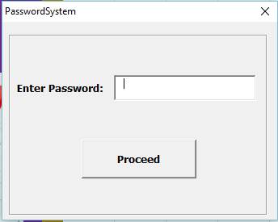

Upon clicking the “Proceed” button, **user authentication** is carried out. The password entered here is compared with the pre-set password in the code. This password is case sensitive, thus the password input must be exactly the same.

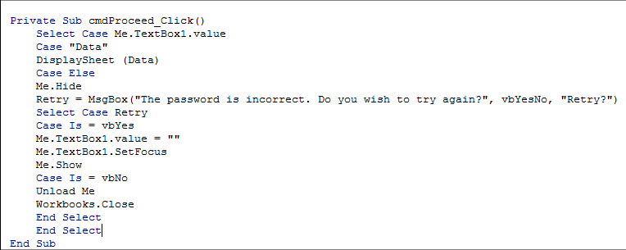

The password input in ‘TextBox1’ is selected and compared to the **Case** “Data”. If there is a match between the two then the user is given access to the sheet “Data”, else an error message is displayed asking the user if they might want to retry. If the user chooses to retry then the cursor is set on ‘TextBox1’ for the user to type the password again, else the workbook is closed.

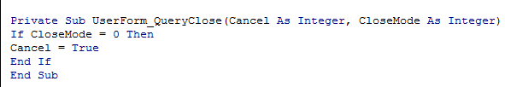

To add a layer of security and to prevent the user from bypassing the password system, the code above ensures that the user cannot close the password user form or access other parts of the application until the correct password is entered.

If the password matches the pre-set password the program leads the user to the “Data” sheet; however, if it does not then the following error is shown:

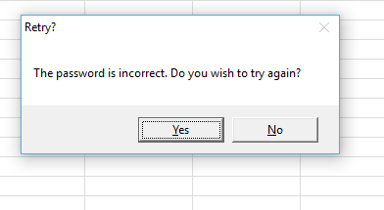

This is the user form which greets the user first immediately after the user opens the application. It serves the purpose of adding security to the application and restricting unauthorised access into the application, thus securing all the data and records saved in the spread sheet. This way only the authorised personnel would be able to add, delete and modify the sale records.

1. POS System:

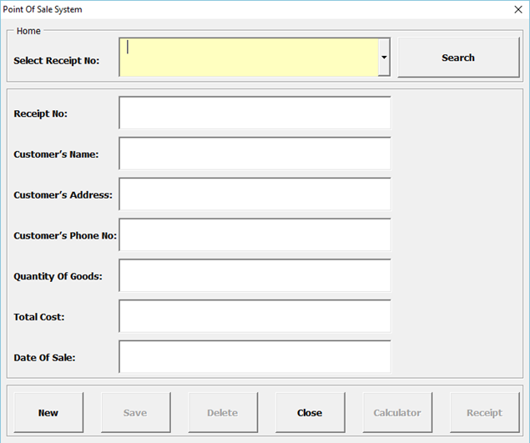

* 1. Search
     1. This enables the user to find previous sales to either editor delete them.

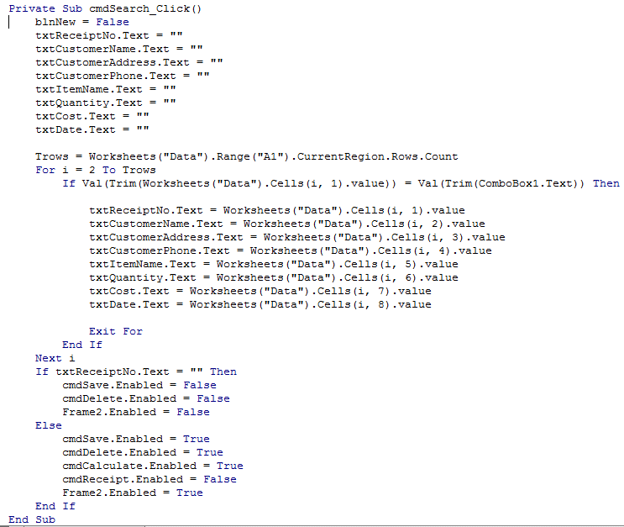

**Trows** is defined as the last row that is used in column A. If the value in ComboBox1, which is the drop down menu, is equal to the value present in rows from 2 to Trows then the other corresponding values such as Receipt No, Customer Name, Item Name, Quantity, Cost, Date, etc. must be copied from the “Data” sheet and be pasted into the appropriate corresponding text boxes present in the user form. The search process is accomplished through the **For** function which iterates between the row 2 to Trows.

* 1. Save
     1. New Entry

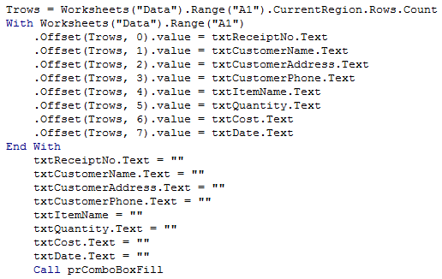

If a new entry is being made then the cursor in sheet “Data” will move to the next unoccupied row and traverse through each cell column-wise and set these cells to the values in their corresponding text boxes in the POS System User form. Once these changes have been made to the sheet “Data”, the text boxes in the POS System User form will be cleared.

* + 1. Existing Entry

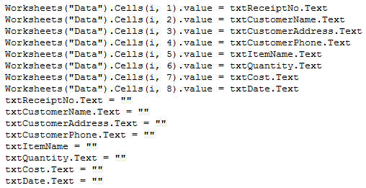

If a change is being made to existing entry then the cursor in sheet “Data” will move to the row which contains values that correspond to the values present in the text boxes of the POS System User form. It will then update these values in the sheet “Data” by updating the values with values present in the POS System User form after which the text boxes in the POS System User form will be cleared.

* 1. Delete

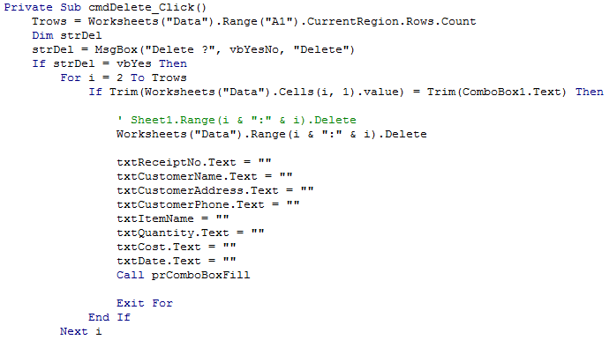

When a record is deleted the user will receive a message box from **strDel** asking the user if he wants to continue with the deletion of the values in the sheet “Data” corresponding to those present in the text boxes of the POS System User form. This program searches for the Receipt No. in ComboBox1 in the sheet “Data” through a For iteration and If statement, once the match is found the values from sheet “Data” will be deleted and the text boxes in the POS System User form will be cleared.

1. Receipt:

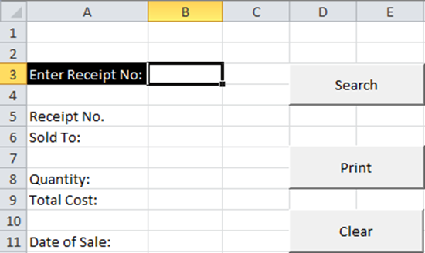

* 1. Search

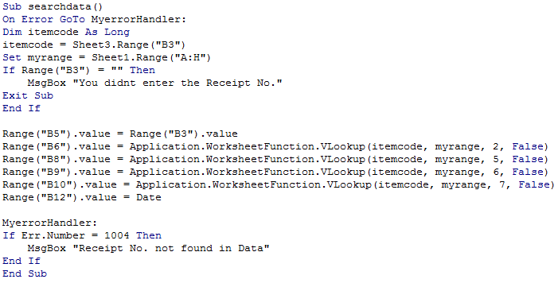

When the user inputs the Receipt No. in the cell “B3” of sheet “Receipt” and clicks the “Search” button, this program is executed. If the cell “B3” is blank then it outputs an error message, otherwise it would use **VLookup** in order to set the values in cells B6, B8, B9 and B10 of sheet “Receipt” with corresponding values from sheet “Data” that have the same Receipt No. If the Receipt No. input into cell “B3” does not exist in sheet “Data” then an error message is output.

* 1. Print

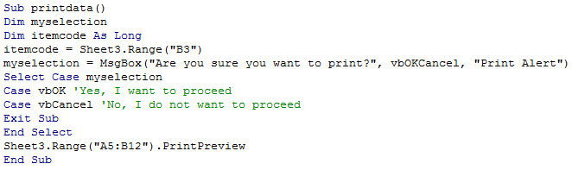

If the user clicks on the “Print” button then this program is executed whereby the program will first ask the user if they want to continue with the print command, if the user proceeds the program will create a print preview for the data between the range A5 and B12, otherwise it will go back to the sheet “Receipt”.

1. Stock:

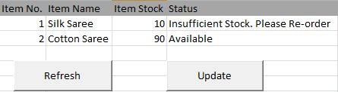

* 1. Save
     1. New Entry

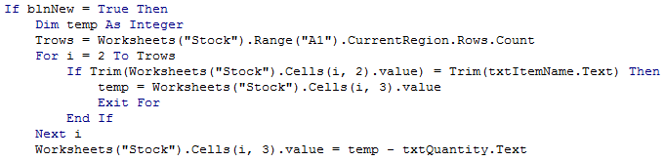

When the user clicks the “Save” button in the POS System User form, this program will use a For iteration and go through the Item Name listed in the sheet “Stock” row-wise and compare these values with the Item Name in the Item Name text box in the POS System User form, once the match is found the corresponding Stock quantity in the sheet “Stock” is set as an integer **temp** after which the values stated in the Quantity text box in the POS System User form is subtracted from the value temp, thus updating the stock quantity.

* + 1. Existing Entry

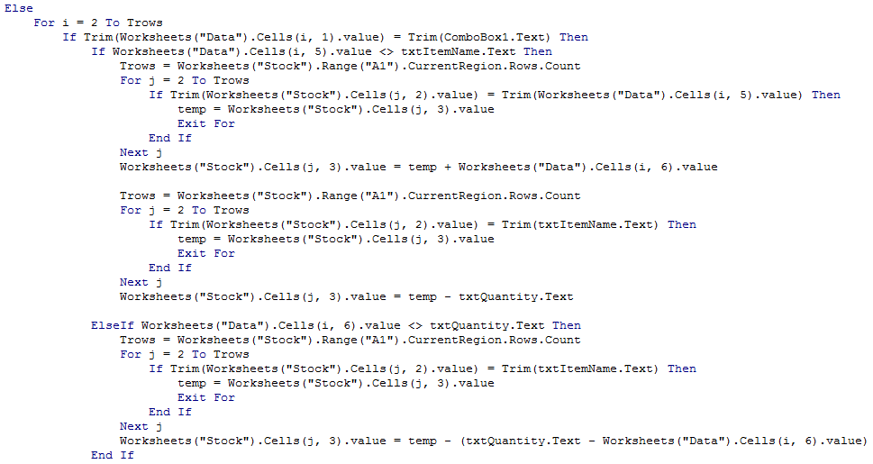

If the entry already exists then the program will first check if the Receipt No. in sheet “Data” is equal to the value in ComboBox1, once that is found it will check if the Item Name has been updated, if it has been then the quantity that was initially subtracted from the stock quantity will be added back to the Item Name in the sheet “Stock”. Additionally, the same quantity that was added back to the previous Item Name will be subtracted from the updated Item Name in the sheet “Stock”. However, if the Item Name has not been updated rather the Quantity if updated then the previous Quantity is added back and the updated Quantity is then subtracted from the Quantity in sheet “Stock”.

* 1. Update

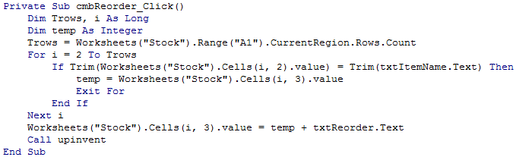

When the “Update” button in sheet “Stock” is clicked then the value in the Item Name text box from the Reorder Stock User form is compared with the list of values in the Item Name column in sheet “Stock” row-wise, once the match is found the corresponding Item Stock in sheet “Data” is set as temp and the value input in the Reorder Amount text box in the Reorder Stock User form is added to this temp value. Thus the stock is added and updated.

* 1. Validation

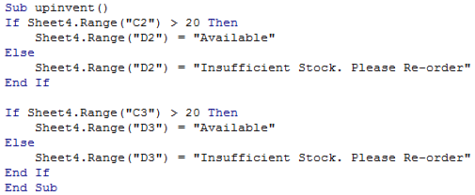

When the **upinvent** subroutine is called the program will conduct validation checks on the quantity of stock. If the quantity is greater than 20 then the status will show “Available” in the cell “D2”, otherwise the status will be updated to “Insufficient Stock”.

1. Graph:

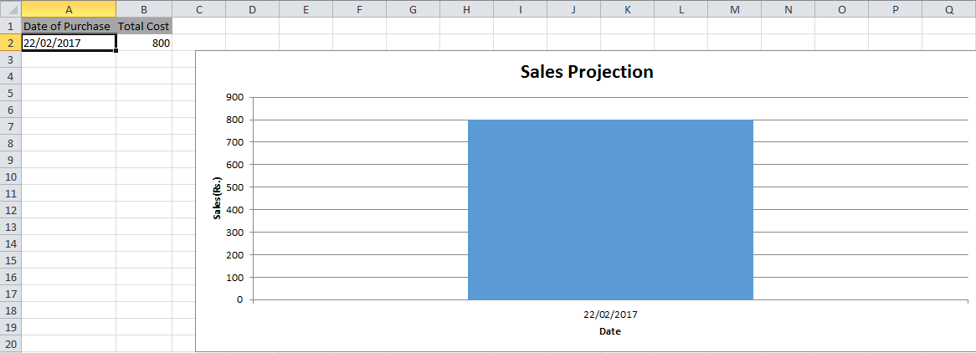

* 1. 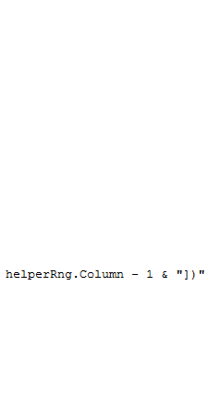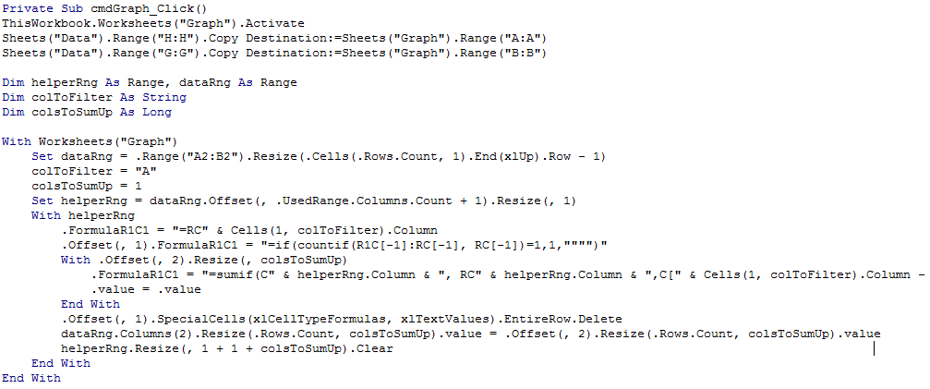Generate

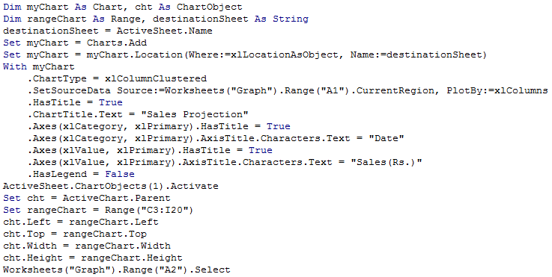

When the “Generate Graph” button in sheet “Data” is clicked, the program will combine rows in terms of duplicate dates in column “H” (i.e. if two different sales are made on the same date then the program will combine these two rows into one by summing the multiple revenue made on the same date.) The column of dates and the new column of revenue will be used to create a new table in the sheet “Graph”. The new 2 column table in the sheet “Graph” will then be used to generate a column graph named Sales Projection in the range “C3” to “I20” with the Date, from column “A”, on the x-axis and Sales (Rs.), from column “B”, on the y-axis.

|  |  |
| --- | --- |
| Page Name | Function |
| Login | This page is responsible for granting the user access to the application only after obtaining the correct password. |
| POS System | This page is primarily responsible for searching, adding and deleting records from the “Data” sheet. |
| Receipt System | This page is responsible for searching the fields that correspond to the Receipt No. input by the user and printing a Receipt from the fields obtained. |
| Stock System | This page is responsible for tracking and updating the stock number and stock status, for each of the items present, after a sale or reorder. |
| Graph System | This page is responsible for generating sale trend graph using the Cost of Sale and Date of Sale fields from the “Data” sheet. |

**Word Count: 1260**